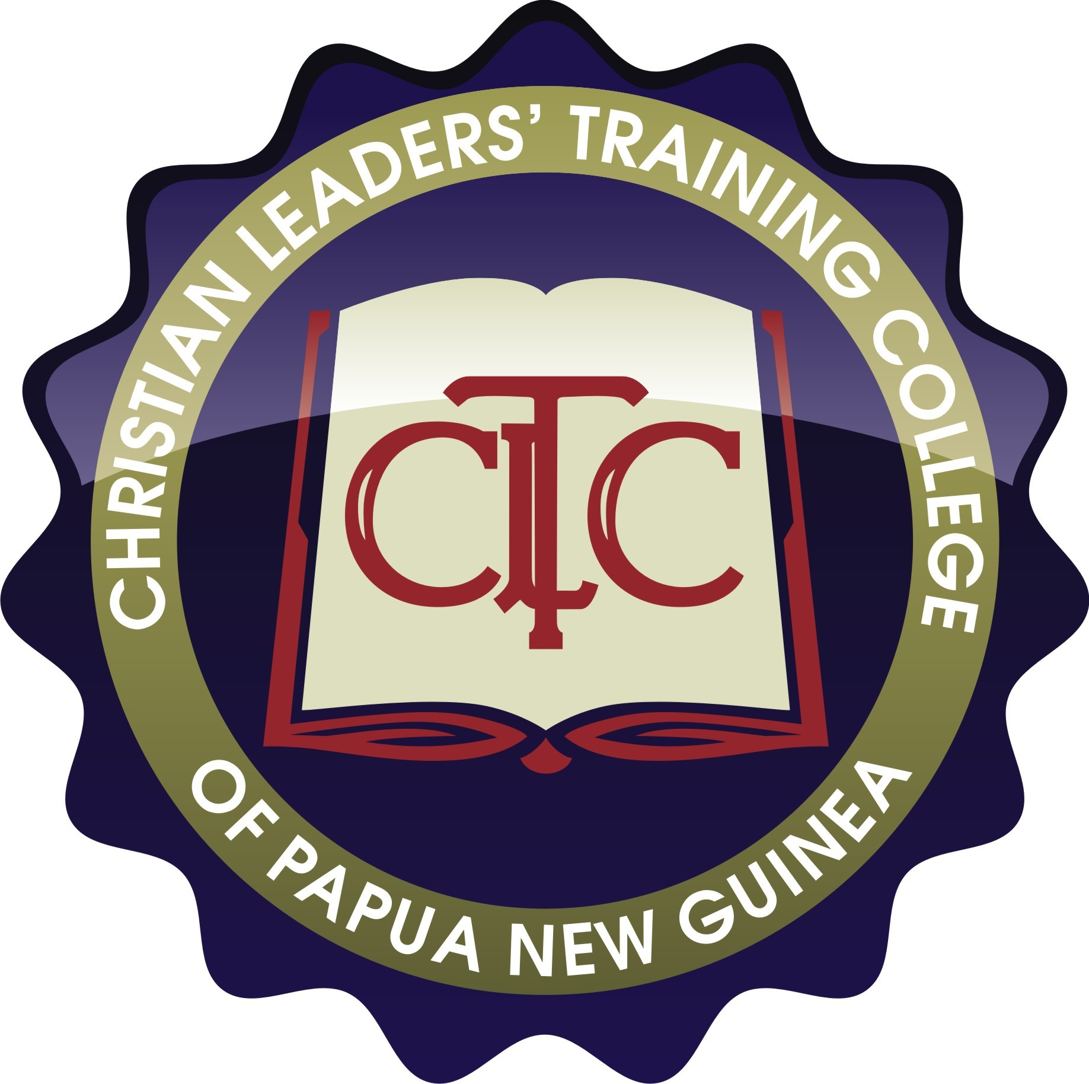Christian Leaders’ Training College of Papua New Guinea, Inc.


“Serving the Churches of the South Pacific Islands”
.National Principal
Rev. Dr. William K. Longgar

P.O. Box 382 Ph: (675) 276 5028
Mt Hagen, WHP Fax: (675) 276 5029
Papua New Guinea Email: cltc@cltc.ac.pg

PA to PRINCIPAL’S JOB DESCRIPTION

Position: PA to PRINCIPAL Hours: Full-time (40 hours per week)
Location: Banz campus Contract Duration: 2 year
Department: S&S Salary Level: to be negotiated depending on experience
Reporting to: Principal and qualifications

A. PURPOSE

To ensure and provide the overall administration functions and clerical duties for the Office of the Principal.

B. MAIN COMPONENTS

- Ensure that the Administration functions in the Office of the Principal are functional.
- Ensure to assist the Principal to organise Special Meetings and Functions.
- Assist Principal to prepare for MET Meetings and preparations.
- Ensure to assist Principal with CLTC Council and Association Meetings preparation.
- Personal Assistant Office

C. DETAILED TASKS

- ENSURE THAT THE Administration functions in the Office of the Principal ARE FUNCTIONAL
  - Ensure (Daily) that PA’s office is in all necessary condition for use and proper function.
  - Ensure (Daily) that Principal’s office is in proper condition for use and proper function.
  - Assist the Principal on daily basis on his appointments, responsibilities and programme for the week/month. To monitor all daily appointments for the Principal in accordance with the Weekly/Daily briefing programmes.

  - To attend to details in preparation for the Principal’s briefing and meetings during the week in consultation with Department Supervisors and Staff.

  - Ensure that Office of the Principal Filing System is up to date.

- Ensure to assist the Principal to organise Special Meetings and other Functions and other matters.
  - To consult the VPA, VPE and Department Supervisors on Principals Weekly/monthly programmes. Work closely with VPA and the other Department Supervisors as direction by the Principal.

  - Assist Principal and VPA to prepare College Staff Meetings, Staff Functions and farewell parties and bung kai and other important events of the College.

  - Assist Principal and College Chaplain to organise spiritual programmes of the college. Eg. Commencement Service, Staff Bible Studies and etc…

  - Prepare and do “College Harim News” then distribute it to everyone in the College Community, Supporters and Prayer Partners both PNG and Overseas.

  - Assist Principal to prepare and send out the “Principal’s Newsletter” on quarterly basis every year to College Council members, College Community, Supporters and Prayer Partners both in PNG and Overseas.

- Assist Principal to prepare for MET Meetings.
  - Prepare and send notices to MET members one week in advance prior for their meeting.
  - Prepare MET Meeting Agendas.
  - The PA to Principal is automatically the Minute Secretary of the MET Meetings and always be prepared to take minutes for other meetings when ask to.
  - Be always prompt with minute taking and informing the MET Team about the decisions made for appropriate action.

- CLTC COUNCIL AND ASSOCIATION MEETINGS AND PREPARATION

  - Ensure that CLTC Association Membership List is updated every year.

  - Assist Principal to prepare Council AGENDAS for the Council Meetings.

  - Ensure that Notices and the “Information Letter” for Council Meetings are sent to two to three months prior to the Council meetings.

  - Formal notice to be sent to inform Council members with proposed list of Council members names to confirm their travel arrangements with their exact dates of coming and going.

  - Send also the previous Council Meeting Minutes & Summary Decisions for further consideration reading and action.

  - Send email notice to MET, Divisional Head, Department Managers and the Urban Campuses Dean to work on their reports and send them in for compiling.

  - Ensure to contact all Council members by email & phone to confirm their travel arrangement. And work on their bookings as soon as possible.

  - Arrange Devotion Speakers for Council Meetings and inform them in advance.

  - Present all reports to the Principal for final confirmation and binding.

  - MET to consider reports, budgets and make recommendations to Council. Send the reports to the Council members for two weeks in advance for reading before they come for the meeting.

  - Finalize all accommodation and meal arrangements for Council members. Consult the guesthouse manageress for the need for shopping and stocking of food stuff. Consult and confirm with Transport Officer for the transportation of Council members coming and going.

  - Get the Council meeting folders ready.

  - Get the venue ready for the meeting.

  - Minute takings when ask to do. Prepared to be a Minute Secretary for Council meetings when invited to by the Principal as the Council Secretary.

- Personal Assistant Office

  - Ensure that your office is well set up for easy and effective function.
  - Ensure your computer is available for your use connected to a printer and working efficiently.
  - Ensure that you are connected to the email and your phone is working at all time.
  - Get the necessary stationary required for the office from the General Office.
  - Your office notice board should have the latest information necessary for references.
  - Office set-up be organized and allow effective function.
  - Office Cabinet properly placed, organized in the relevant office filing system.

D. KEY RELATIONSHIPS

- Accountable to the Principal as his PA
- Vice Principal Administration
- Management Executive Team
- Chaplain

E. QUALIFICATIONS AND EXPERIENCE

- At least have 5 years experience or more secretarial work in the office of Chief Executive Officer.
- Must be a Diploma/Degree holder in Secretarial studies and Office Administration/Management.
- Must be a Computer literate.
- Must know how to take meeting minutes
- Be able to make travel arrangements, bookings and transport
- Ability to switch between strategic and operational mindset
- A pastoral heart
- Understanding of and adherence to the CLTC doctrinal statement

- CHRISTIAN VALUES

- Must have a good Christian life testimony
- Be a strong witness to the Word
- Be eager to take part in Christian fellowship

- BE ALWAYS READY AND AVAILABLE TO TAKE UP EXTRA RESPONSIBILITIES

